

14.02.2022

A Project by Vladimir Abuhnoaei

Express yourself

Kwetter

# Project Description

Kwetter is a simplified version of the popular social media platform Twitter. This web application will contain some of the features included in the popular platform in order to show that the learning goals for the semester 6 have been achieved. The process of implementing these features includes planning the use of appropriate frameworks and technologies, planning the backend and frontend structures to include extensibility for the future and optimal solutions for performance and user experience.

This project will focus on a well-structured database, on a proper security system (registration, login, logout), multiple user roles and user functions (access to specific functions of the application based on role) and on an adaptive and extensive design, that can use and reuse multiple elements and be responsive based on the user’s screen of use.

Table of Contents

Project Description 2

1. Project Challenges 4

2. Non-functional requirements 5

3. Achieving the Project 6

# Project Challenges

The project will focus on several important aspects, therefore implying a number of different challenges. These challenges focus on working on a project that fits the Enterprise Software Development:

* Implementing frameworks and technologies that are efficient (do not over cost a set budget, are the most efficient in building the application both for the current development stage and programmers, as well as for future extensibility)
* Implementing a number of features that satisfy the needs of multiple type of stakeholders (owner of the application, regular users, administrative personnel, developers that might work on the future of the application)
* Implementing a proper security system (registration and login/ logout)
* Implementing an efficient responsive design (ease of use for multiple users)
* Having reusable components
* Having an extensive backend/ database
* Delivering an overall high-quality project

# Non-functional requirements

Because Kwetter is a very similar application to Twitter, the non-functional requirements are going to be very similar to the ones specific to the popular social media platform. Therefore, the users of Kwetter will be able to:

* Create his own profile
* Add a profile picture and a name
* Add profile details, bio, location
* See last 10 kweets
* See a list of his followers and the total number
* Follow other users
* Visit other user’s profiles
* React to posts of other users (like/ heart react)
* Search within kweets
* Create a new kweet
* See a timeline of kweets and user activity
* Mention other users
* See mentions of himself by other users
* Follow trends
* See trends
* Login and logout to own account

# Initial UI Designs

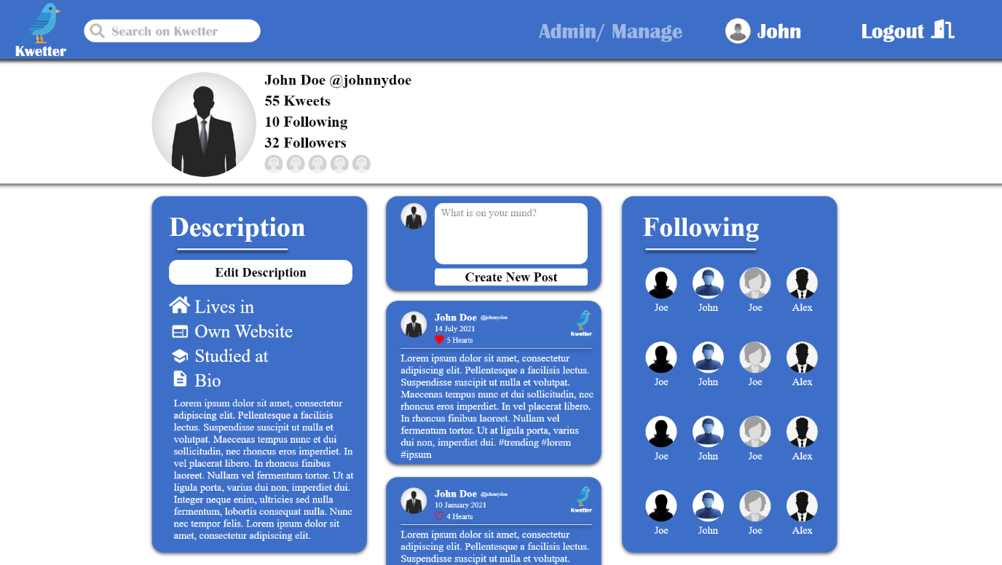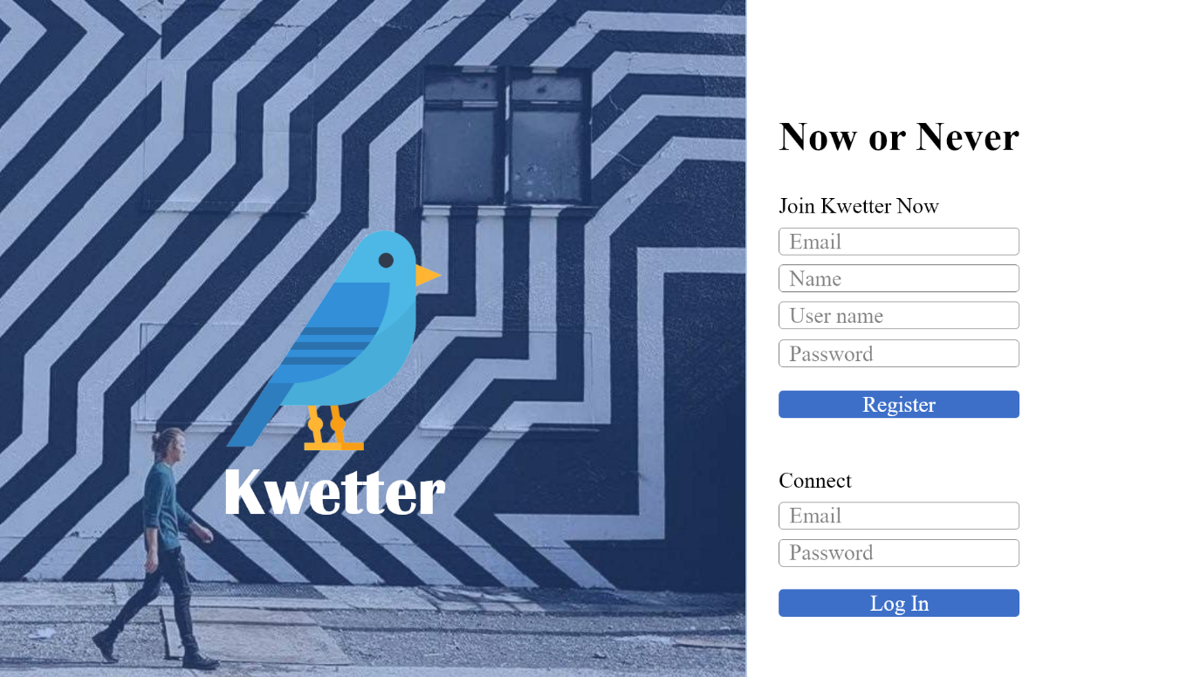The initial designs will be attached to this document. This will show the general look that the web application will have on a desktop device. They are meant to be a general guideline during the implementation of the Front-End component.

Figure . Profile Page

Figure . Registration Page



Figure . Feed Page

Figure . Administration Page

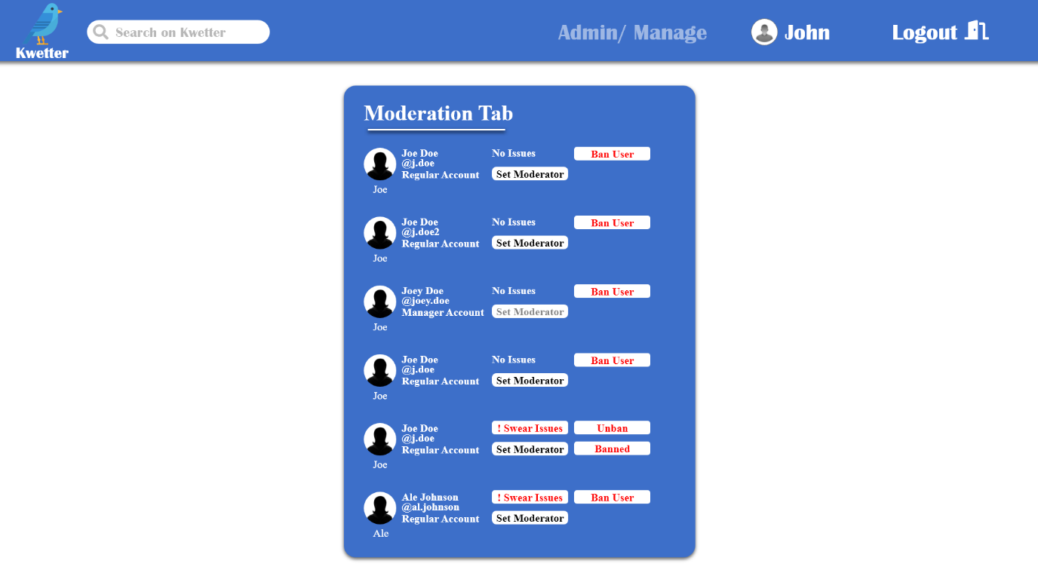

Figure . Moderation Page

# Achieving the Project

In order to achieve the completion of this project it is important to have a plan of the main technologies/ frameworks that will be used during development. Moreover, an analysis of the users and features that will be added will help with planning the structure of the database and design elements. Some of the tool and technologies during the process will be:

* Design Software
  + Adobe XD
* Front End Technologies
  + Vue.js
  + Node.js
  + Chakra UI
  + Tailwind CSS
* Back End Technologies
  + Node.js
  + Mondo DB
  + Docker
* Testing
  + Selenium
  + Jest
* Planning
  + Jira
* Storing / Maintainability
  + Gitlab
  + CI/ CD Pipeline